Front End Engineering-II

Project Report Semester-IV (Batch-2022)

Veterinary Care Design



**Supervised By:**

Raveesh Samkaria

**Submitted By:**

Taney Sharma

2210990887

G- 13

## Department of Computer Science and Engineering Chitkara University Institute of Engineering & Technology,

**Chitkara University, Punjab**

# ABSTRACT

This project summary details the development of a front-end website for a veterinary care service using React.js. The website is designed to provide comprehensive information about the veterinary clinic, including team members, services offered, recent posts, and promotional content. The website's layout and functionality are structured using React components, ensuring a dynamic and responsive user experience. Key sections of the website include an informative navbar, detailed "About" section, service descriptions, and a promotional advertisement area. The implementation leverages CSS for styling and animations, along with the AOS library for smooth scrolling effects, highlighting the clinic's commitment to modern, user-friendly digital experiences. The primary objective is to effectively communicate the clinic's capabilities and services to potential clients, ensuring easy navigation and accessibility across various devices.

The veterinary care website developed using React.js effectively communicates the clinic's capabilities and services to potential clients. By combining dynamic React components, modern animations, and responsive design, the website provides a high-quality digital experience that reflects the clinic's commitment to excellent veterinary care.

FEE-III, 22CS0014

2

# Table of Contents

|  |  |  |
| --- | --- | --- |
| **Sr.no** | **Section** | **Page No.** |
| 1 | Introduction | 4 |
| 2 | Problem Statement | 5 |
| 3 | Technical Details | 6-7 |
| 4 | Proposed Design | 8-10 |
| 5 | File Structure | 11-14 |
| 6 | Result | 15-48 |
| 7 | References | 49 |

FEE-III, 22CS0014

3

# INTRODUCTION

The veterinary care website project aims to create a comprehensive and engaging online presence for a veterinary clinic using modern web development technologies. By leveraging React.js, the project emphasizes a dynamic, responsive, and efficient user experience. The website is designed to highlight the clinic's team, services, recent posts, and promotional content, offering visitors an in-depth view of what the clinic offers.

**Objectives**

The primary objectives of this project are:

* Showcase the Veterinary Team: Introduce the clinic's professional team with detailed profiles, including names, roles, and social media links to establish trust and connection with potential clients.
* Highlight Services: Clearly present the range of veterinary services provided by the clinic, ensuring visitors understand the clinic's capabilities and specialties.
* Engage Visitors with Recent Posts: Provide valuable and up-to-date information through a blog section, enhancing the site's relevance and usefulness to pet owners.
* Promotional Content: Utilize visually appealing advertisements and calls to action to promote the clinic’s services and encourage user engagement.
* Responsive Design: Ensure the website is accessible and visually appealing across all devices, including desktops, tablets, and smartphones.
* Enhance User Experience: Implement intuitive navigation, modern animations, and accessibility features to provide a smooth and enjoyable user experience.

FEE-III, 22CS0014

4

# PROBLEM STATEMENT

Veterinary clinics face the challenge of effectively communicating their expertise, services, and care philosophy to prospective clients through a digital platform. Many existing veterinary websites lack user-friendly interfaces, responsive design, and engaging content, which can lead to poor user experiences and low client conversion rates. Additionally, there is often a lack of integration with social media and up-to-date information, making it difficult for clinics to establish trust and connect with pet owners online.

**Key challenges include:**

* **Outdated Website Design: Many veterinary websites suffer from outdated designs that do not reflect the modern, high-quality care provided by the clinic.**
* **Lack of Responsiveness: Ensuring the website is fully functional and visually appealing on all devices is crucial for reaching a wider audience.**
* **Poor User Navigation: Simplifying navigation and making it easier for users to find information quickly is essential for improving user satisfaction and retention.**
* **Low Engagement: By integrating social media and providing regular updates, the website can increase engagement and build a loyal client base.**
* **Communication of Services: Clearly communicating the range and quality of services offered by the clinic helps in attracting new clients and retaining existing ones.**

**By addressing these challenges, the veterinary care website project aims to create a robust, user-friendly, and engaging online platform that effectively represents the clinic's commitment to high-quality pet care.**

# TECHNICAL DETAILS

## React:

## ****Declarative UI:****

## React's declarative approach to building user interfaces allows developers to describe the desired UI state, and React efficiently updates and renders the components as the data changes. This paradigm simplifies UI development and enhances code readability.

## ****Component-Based Architecture:****

## React's component-based architecture encourages modular development, where UI elements are encapsulated into reusable components. This promotes code reusability, maintainability, and scalability, enabling developers to efficiently manage complex UI hierarchies.

## ****Virtual DOM:****

## React utilizes a virtual DOM to optimize UI updates and rendering performance. Instead of directly manipulating the browser's DOM, React compares the virtual DOM with the current DOM state and selectively updates only the components that have changed, minimizing unnecessary re-renders and enhancing performance.

## ****State Management:****

## React provides built-in mechanisms for managing component state, including useState and useContext hooks. These hooks enable developers to manage local component state and share state across components without the need for complex state management libraries.

FEE-III, 22CS0014

6

## CSS

**CSS (Cascading Style Sheets) is a cornerstone technology used for designing and customizing the look and feel of web applications. In React, CSS plays a crucial role in making components visually appealing and responsive. There are various ways to incorporate CSS into a React project, including traditional CSS files, CSS modules, styled-components, and inline styles.**

**CSS Integration in React**

**Here are some common methods to use CSS in a React application:**

**Traditional CSS Files:**

**Create a .css file and import it directly into your React component.**

**CSS Modules:**

**CSS Modules allow you to scope CSS to a particular component, preventing conflicts and promoting modularity.**

**Styled-Components:**

**Styled-components leverage tagged template literals to style your components.**

**Inline Styles:**

**Use the style attribute directly within your component.**

FEE-III, 22CS0014

7

# PROPOSED DESIGN

# 

FEE-III ,22CS0014

8

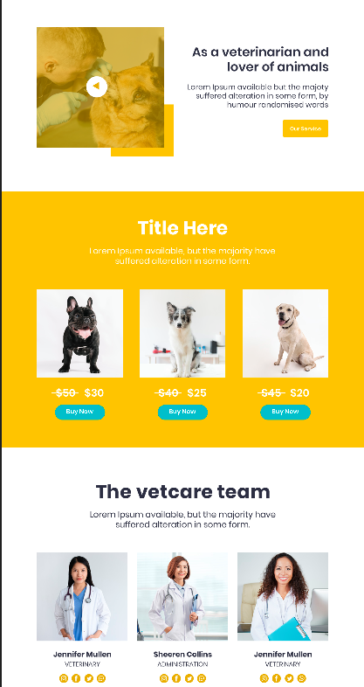

9

FEE-III, 22CS0014

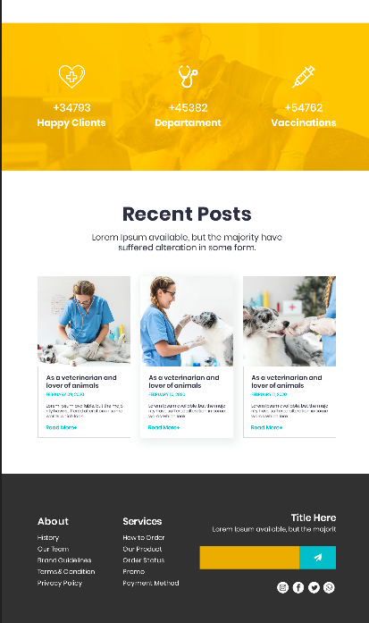

10

FEE-III,22CS0014

# File Structure: -

# vetcare-website/

# │

# ├── public/

# │ └── index.html

# │

# ├── src/

# │ ├── assets/

# │ │ ├── Search_Button.png

# │ │ ├── clog.png

# │ │ ├── doc1.png

# │ │ ├── doc2.png

# │ │ ├── doc3.png

# │ │ ├── Video_icon.png

# │ │ ├── front2shape.png

# │ │ ├── frontdog1.png

# │ │ ├── frontdog2.png

# │ │ ├── frontdog3.png

# │ │ ├── doctor1.png

# │ │ ├── doctor2.png

# │ │ ├── doctor3.png

# │ │ ├── insta.png

# │ │ ├── face.png

# │ │ ├── Twitter.png

# │ │ └── WhatsApp.png

# │ │

# │ ├── components/

# │ │ ├── Navbar/

# │ │ │ ├── Navbar.js

# │ │ │ └── Navbar.css

# │ │ │

# │ │ ├── About/

# │ │ │ ├── About.js

# │ │ │ └── About.css

# │ │ │

# │ │ ├── Advt/

# │ │ │ ├── Advt.js

# │ │ │ └── Advt.css

# │ │ │

# │ │ ├── Dogs/

# │ │ │ ├── Dogs.js

# │ │ │ └── Dogs.css

# │ │ │

# │ │ ├── Service/

# │ │ │ ├── Service.js

# │ │ │ └── Service.css

# │ │ │

# │ │ └── Posts/

# │ │ ├── Posts.js

# │ │ └── Posts.css

# │ │

# │ ├── App.js

# │ ├── App.css

# │ └── index.js

# │

# ├── package.json

# └── README.md

FEE-III ,22CS0014

12

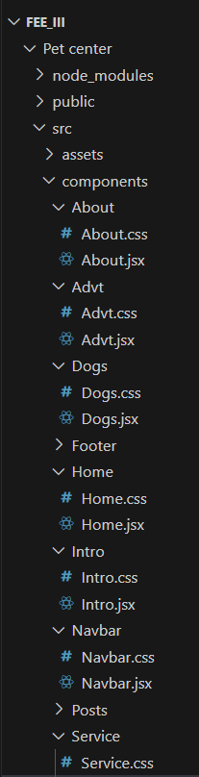

13

FEE-III ,22CS0014

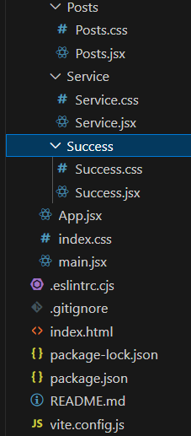

**File Structure**

FEE-III ,22CS0014

14

**CODE**

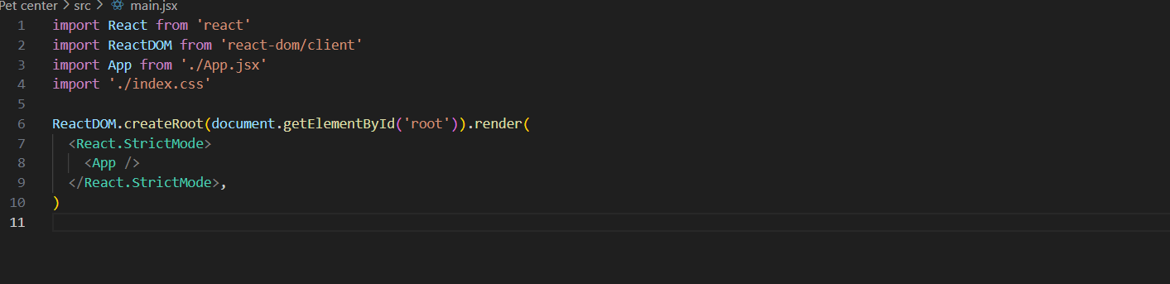

**Main.jsx**

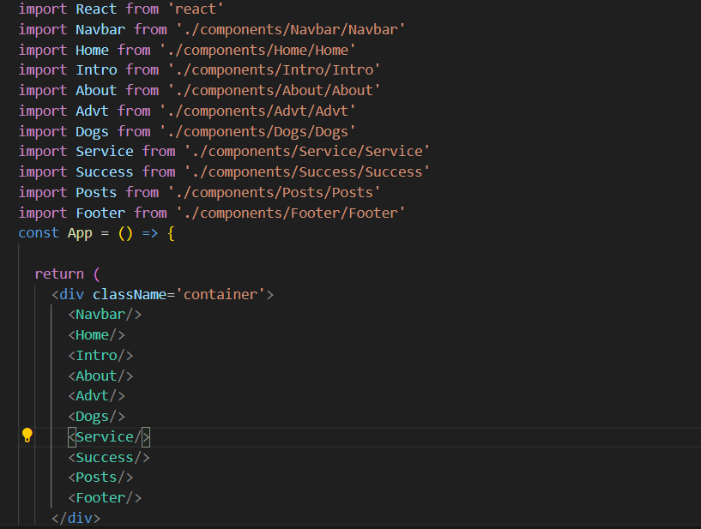

**App.jsx**

15

FEE-III ,22CS0014

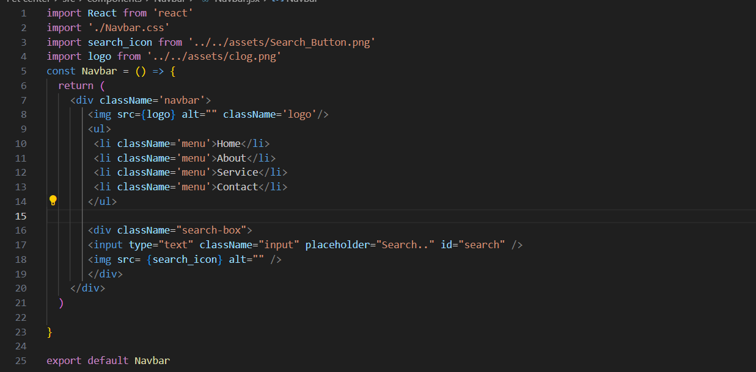

**Navbar.jsx**

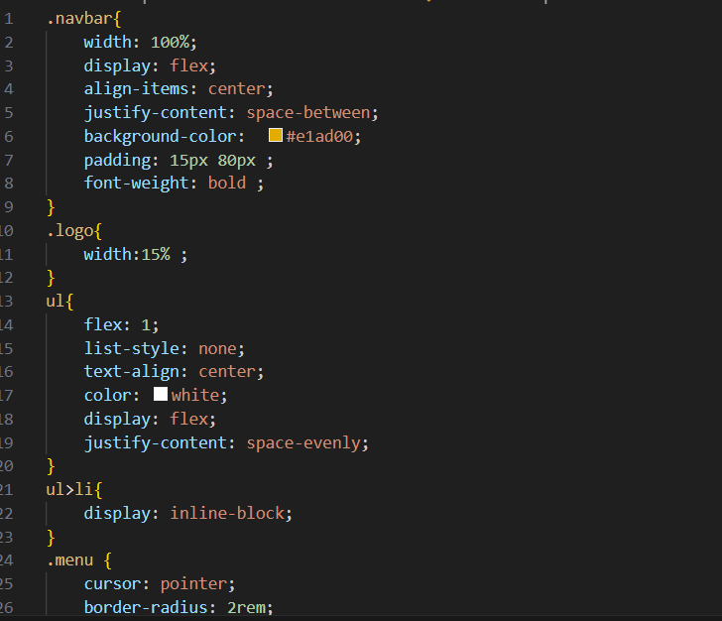

**Navbar.css**

FEE-III ,22CS0014

16

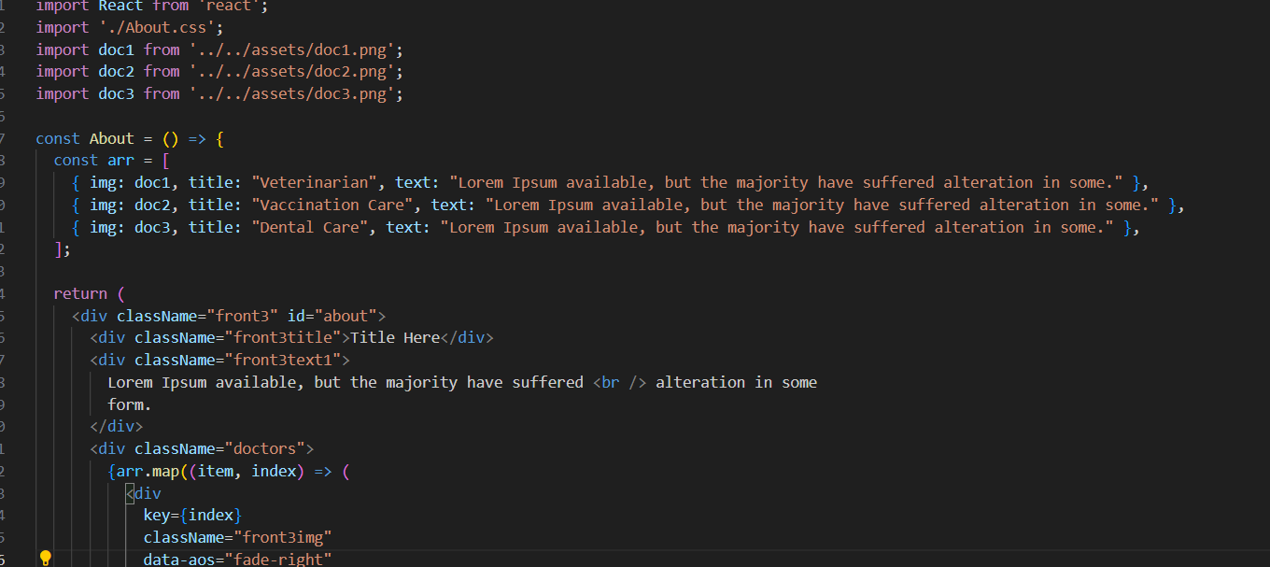

**About.jsx**

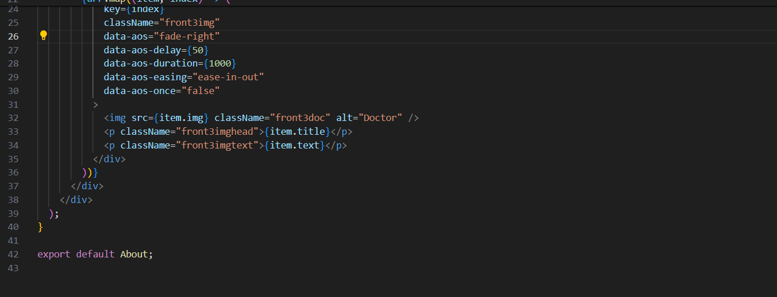

FEE-III ,22CS0014

17

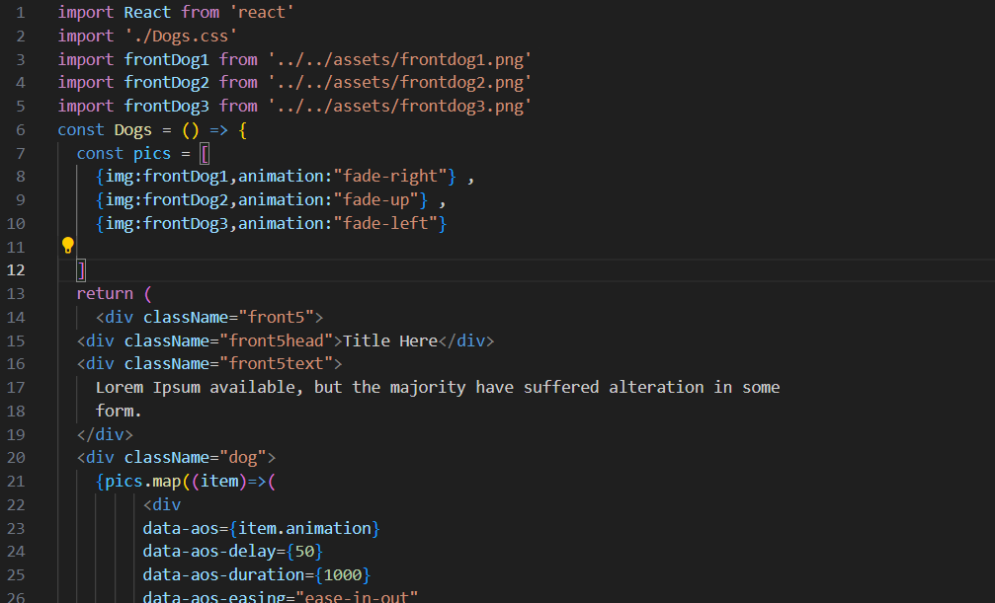

**Dogs.jsx**

FEE-III ,22CS0014

18

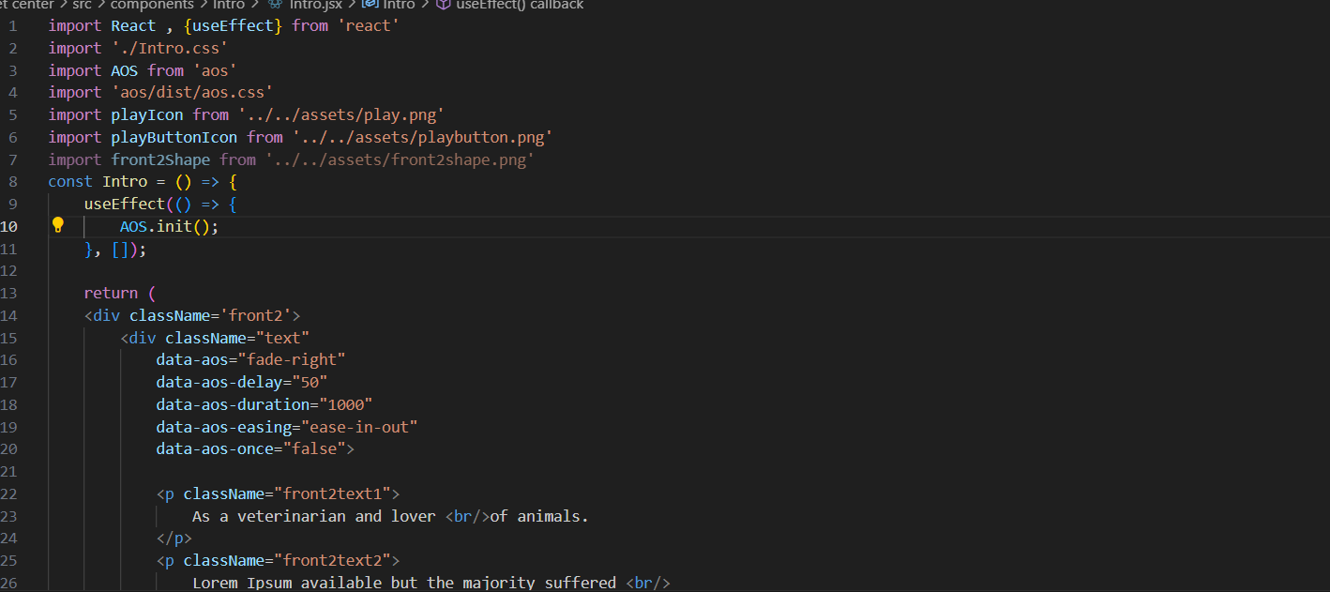

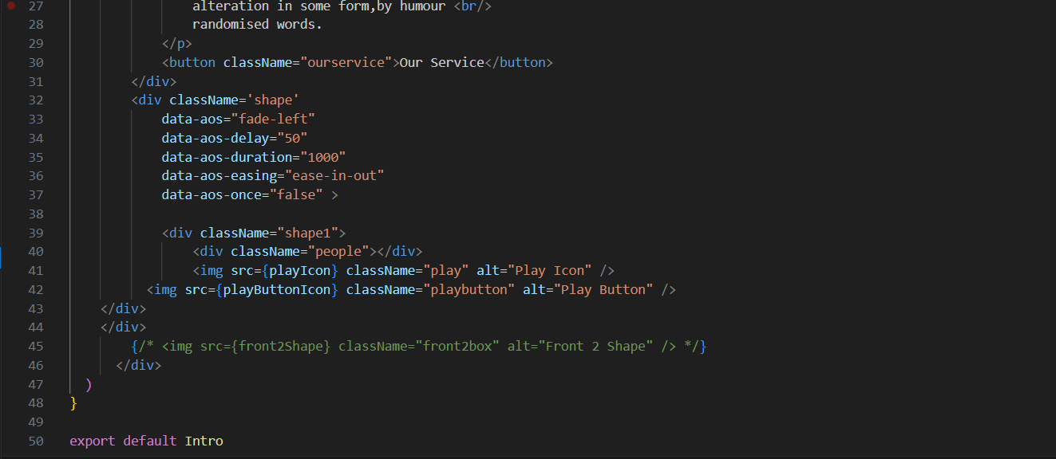

**Intro.jsx**

FEE-III , 22CS0014

19

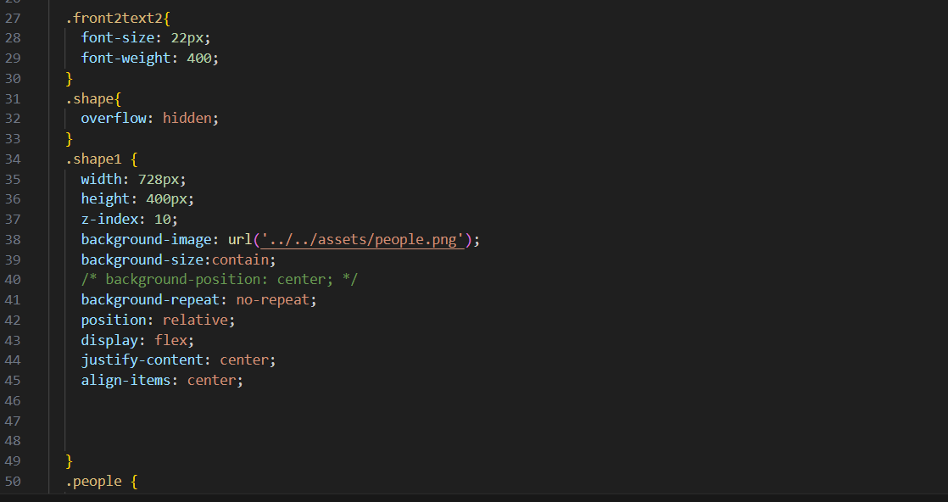

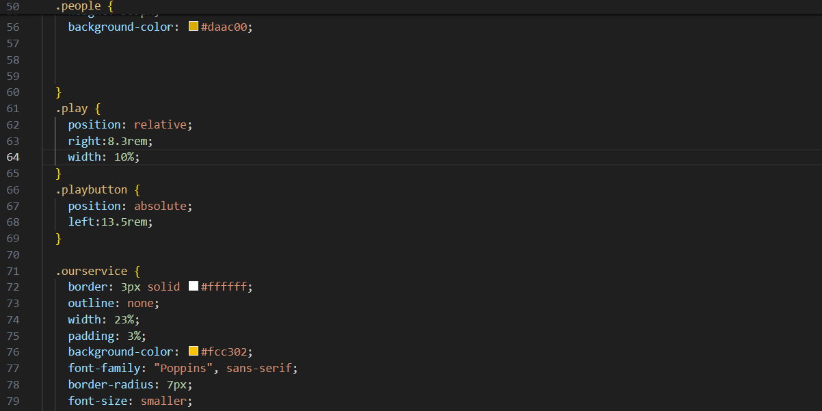

FEE-III , 22CS0014

20

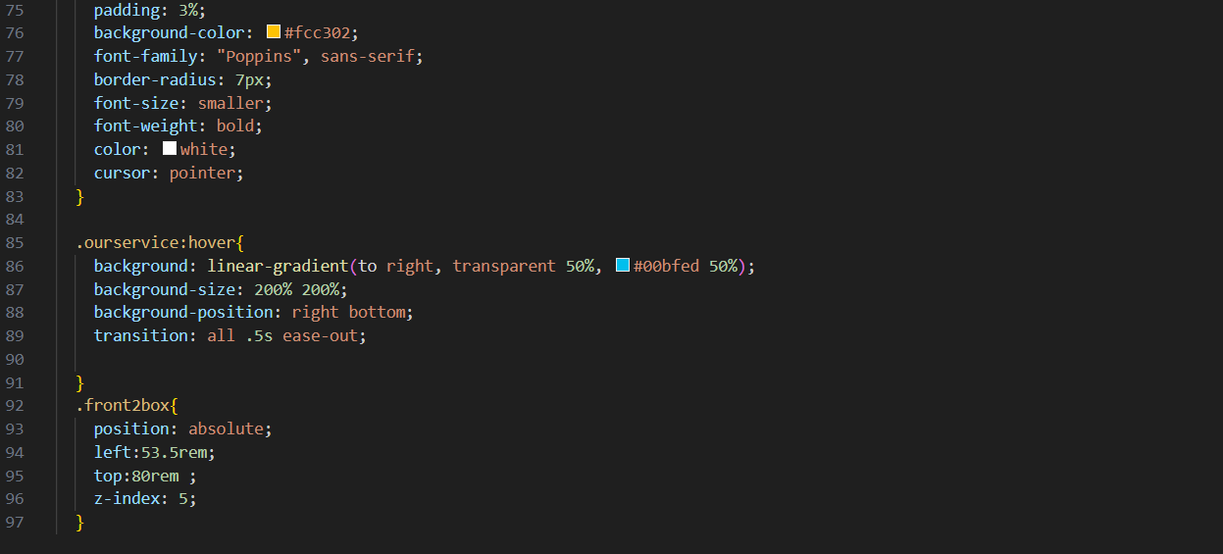

**Intro.css**

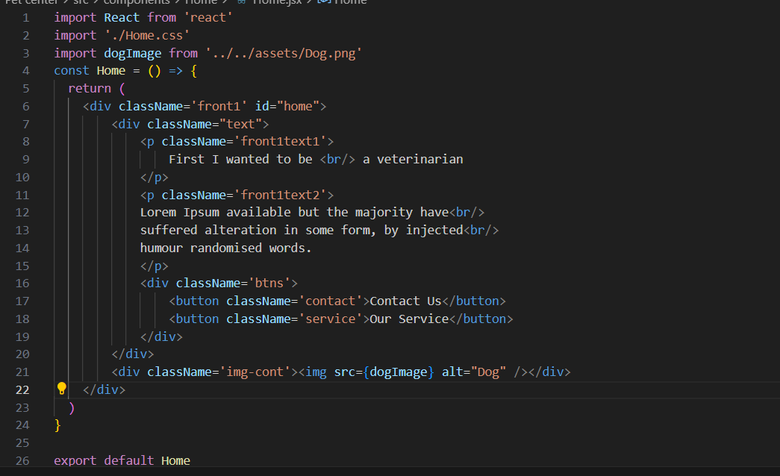

**Home.jsx**

FEE-III , 22CS0014

21

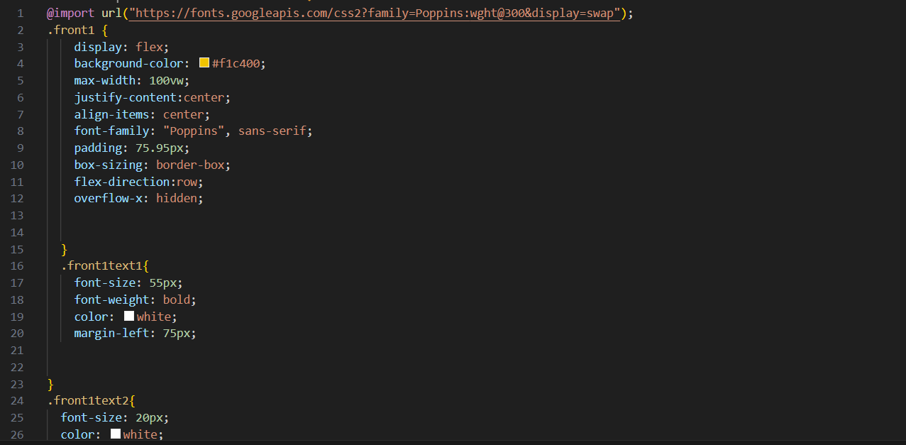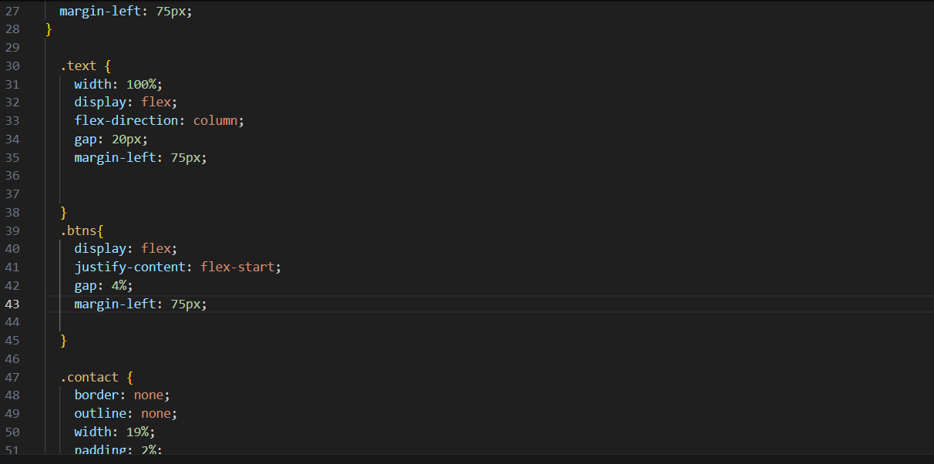

FEE-III ,22CS0014

22

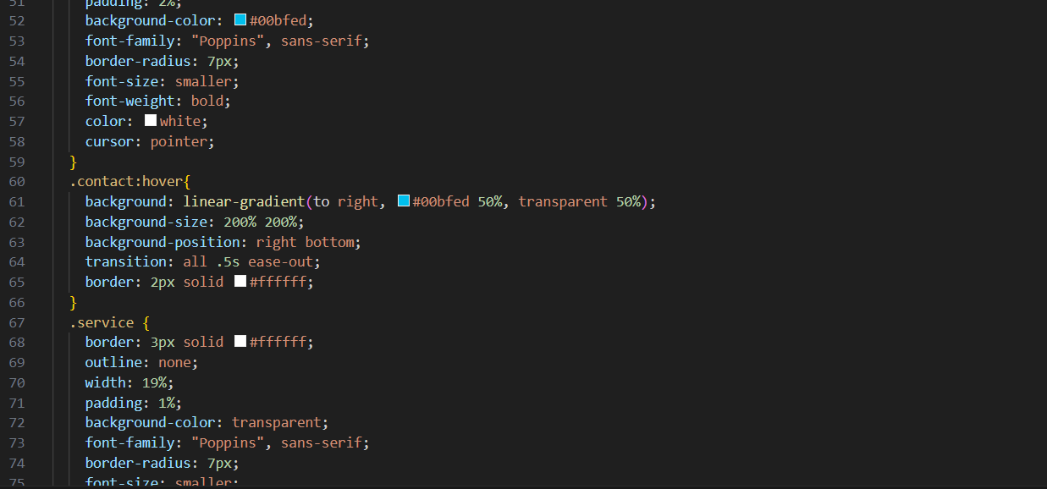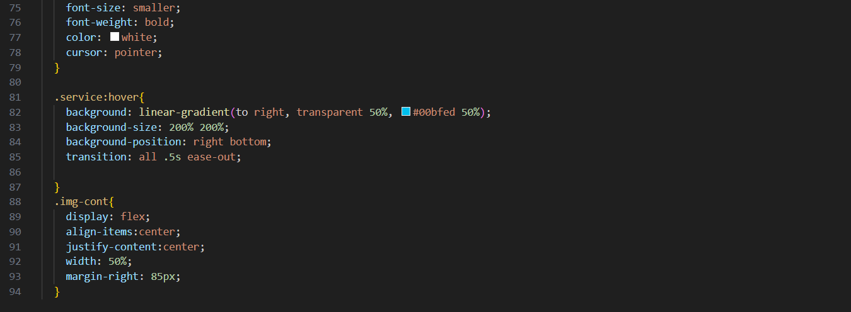

**Home.css**

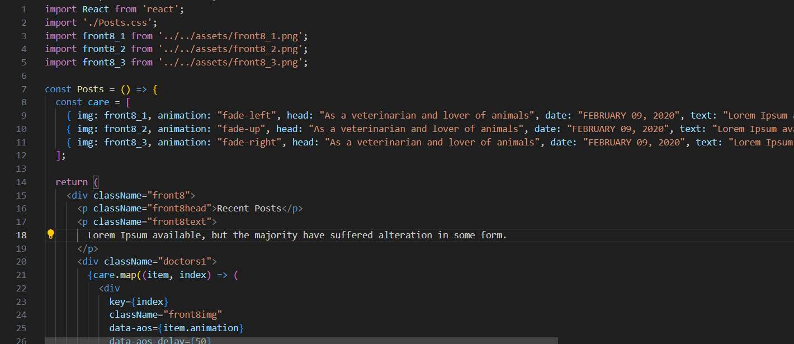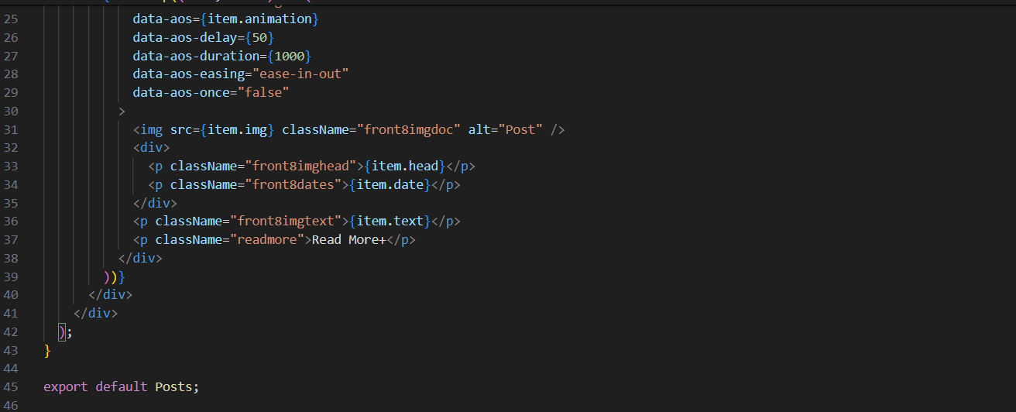

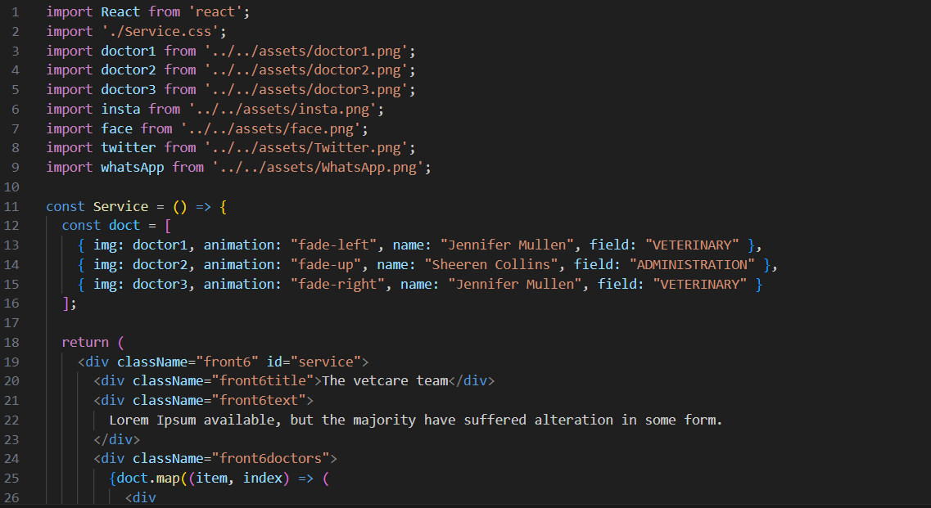

FEE-III , 22CS0014

24

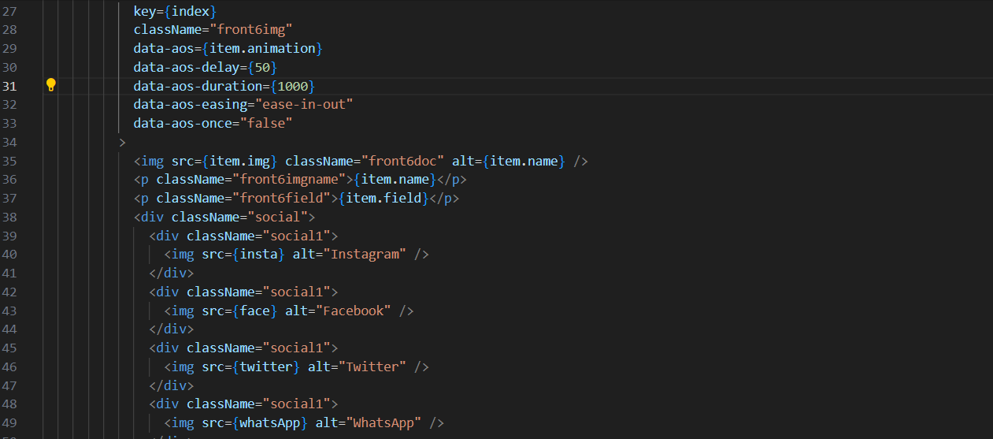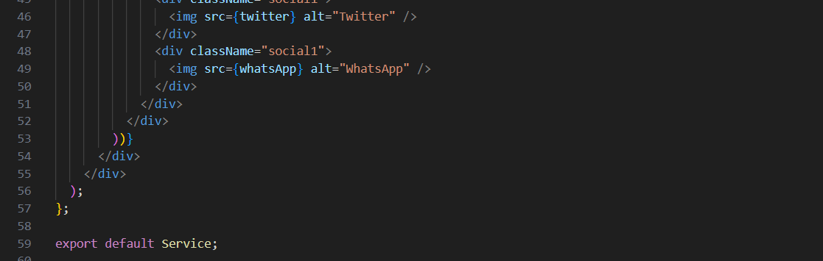

**Service.jsx**

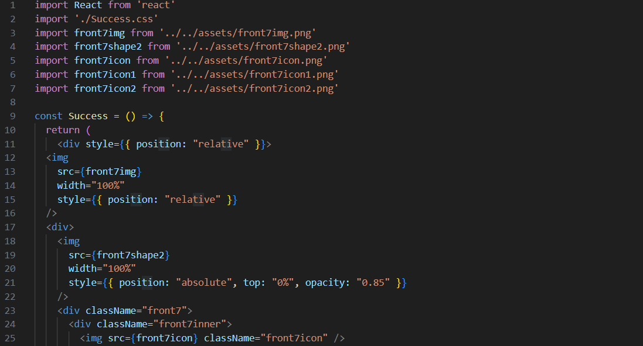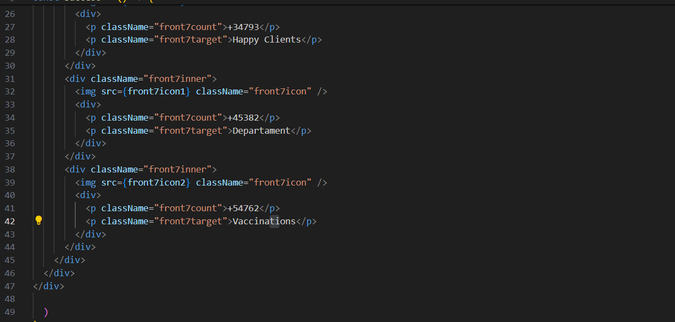

**Success.jsx**

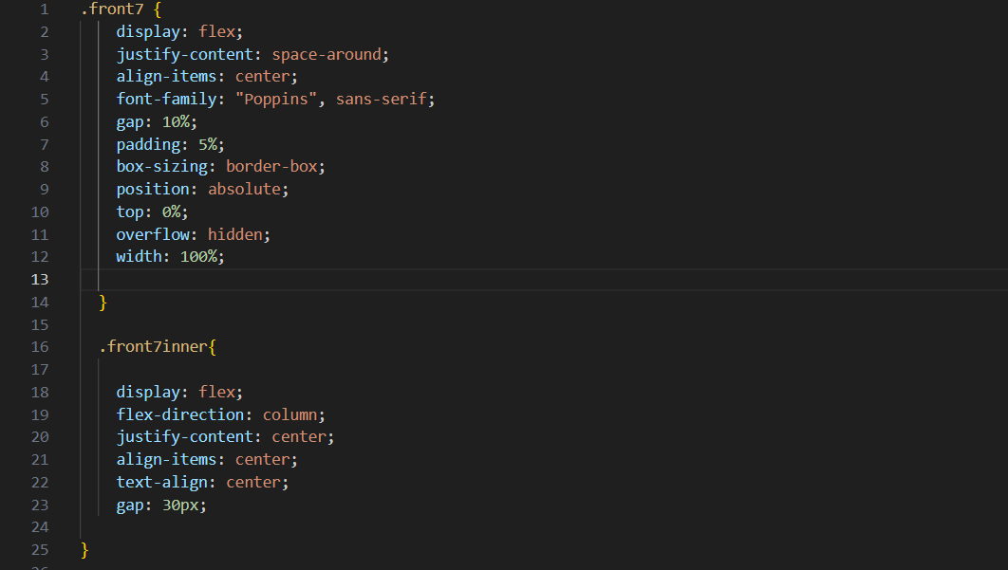

FEE-III , 22CS0014

26

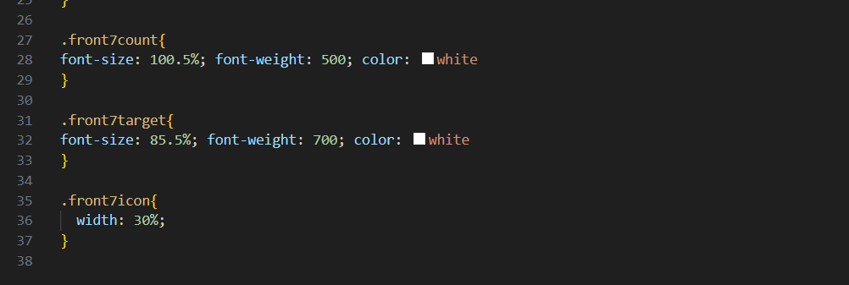

**Success.css**

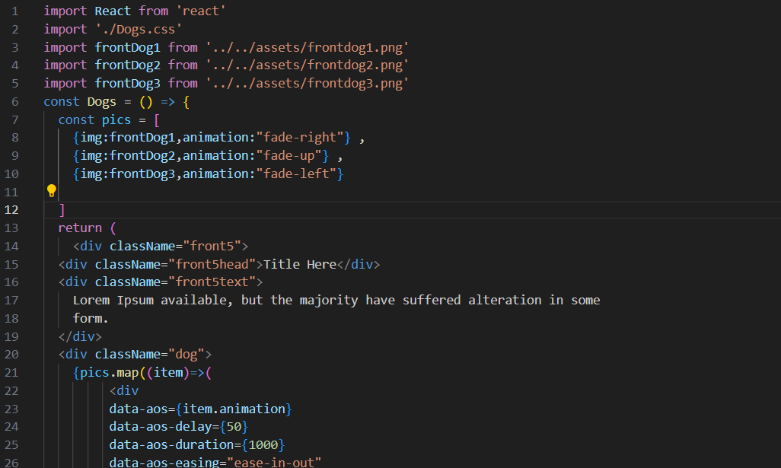

FEE-III , 22CS0014

27

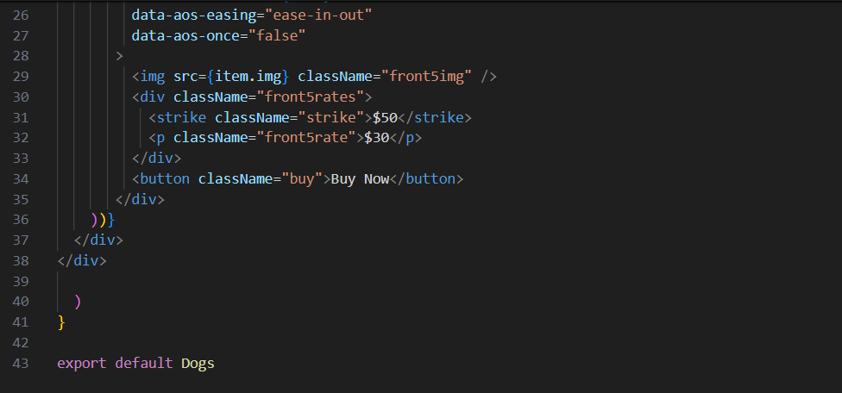

**Dogs.jsx**

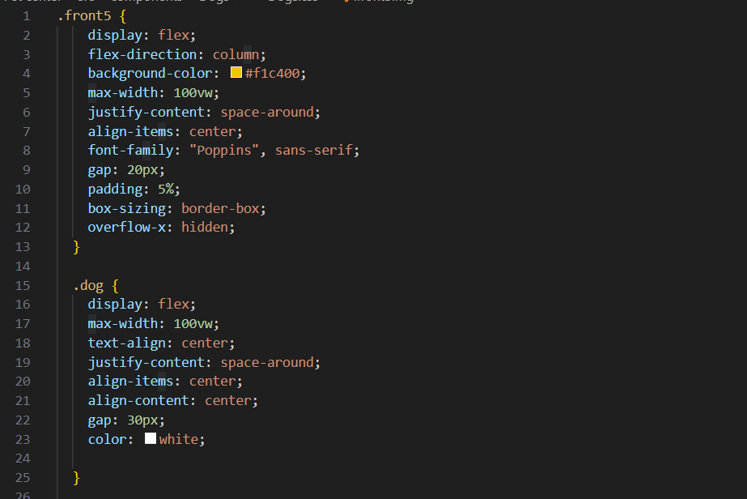

FEE-III, 22CS0014

28

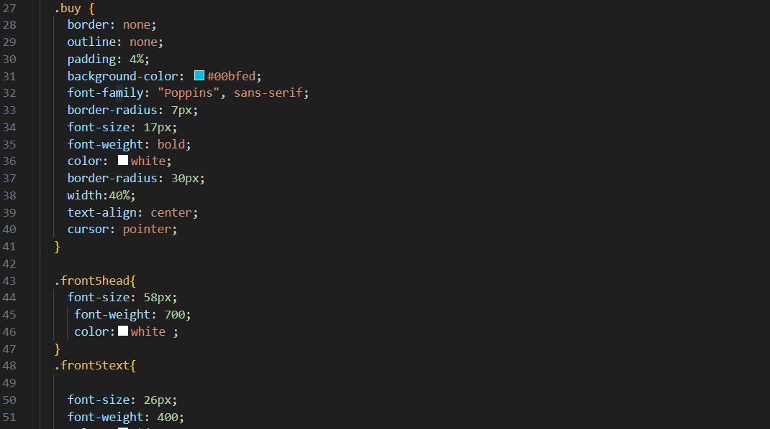

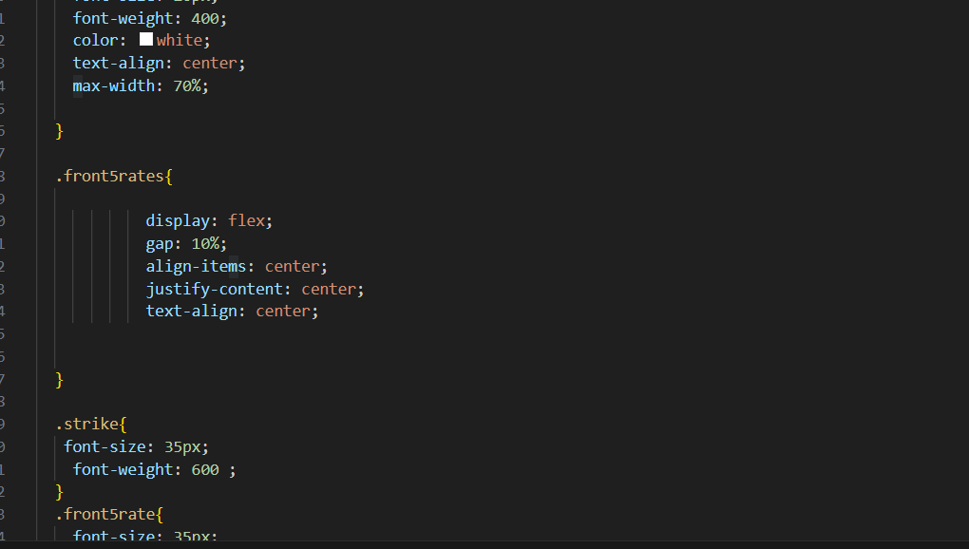

**Dogs.css**

FEE-III ,22CS0014

29

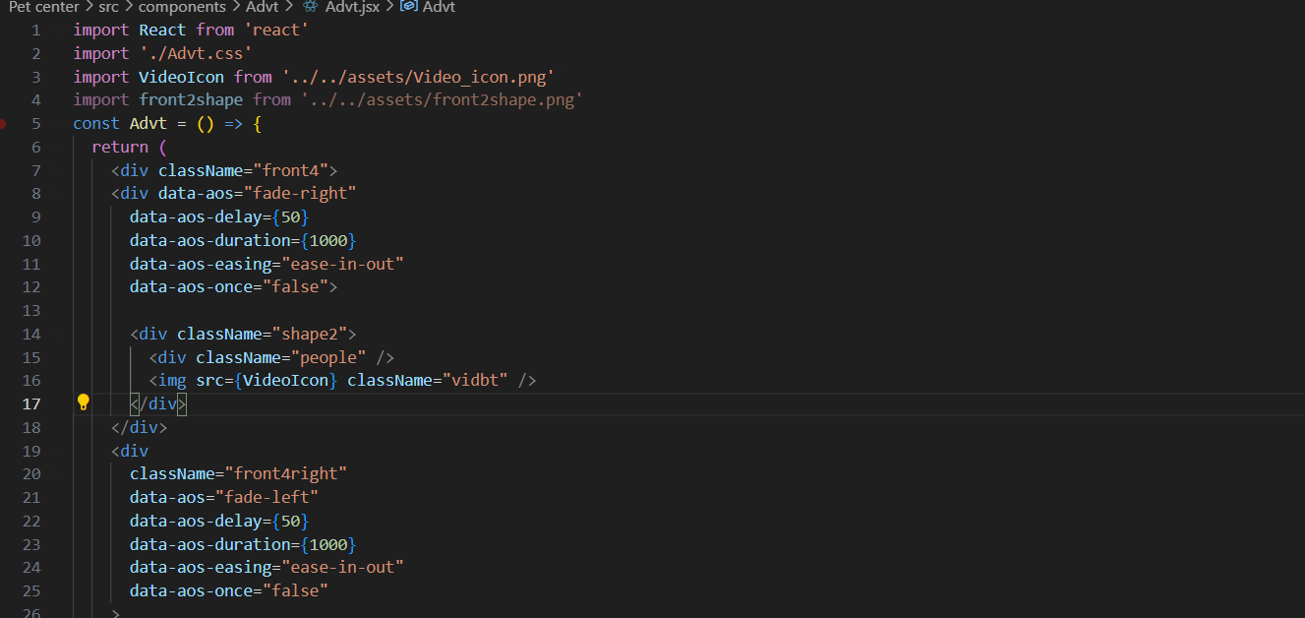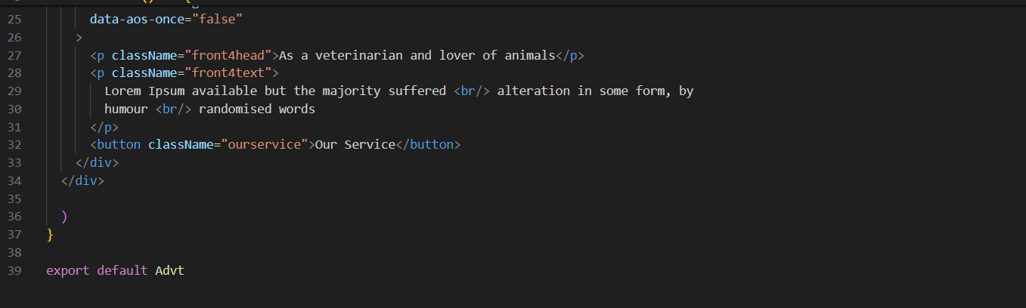

**Advt.jsx**

FEE-III, 22CS0014

30

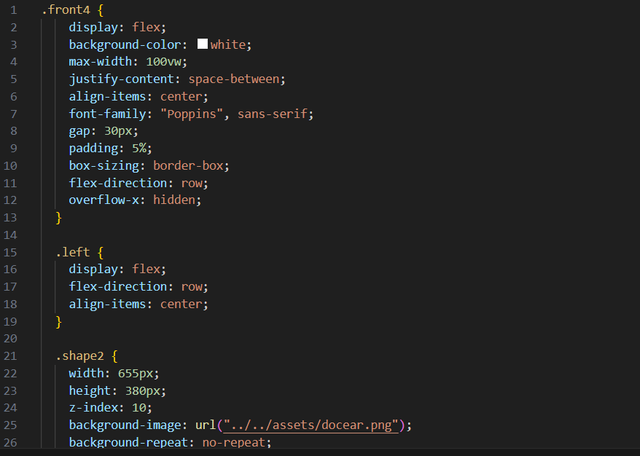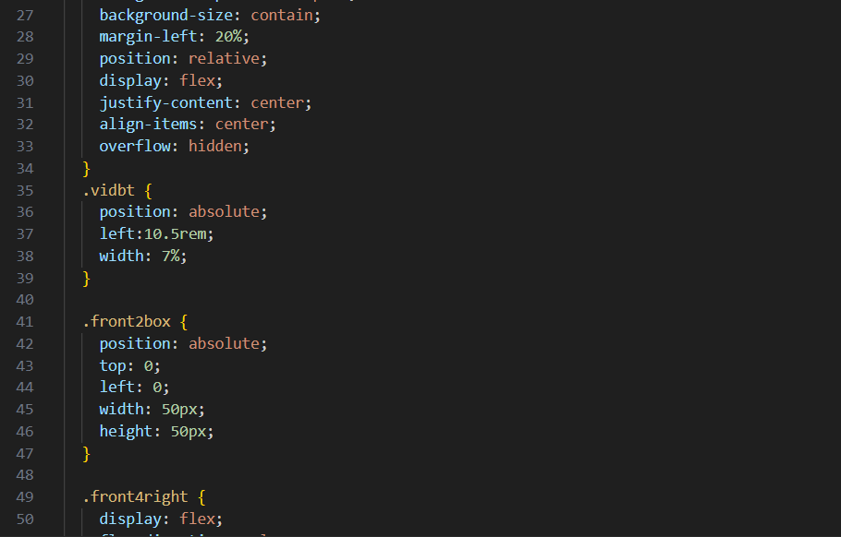

FEE-III, 22CS0014

31

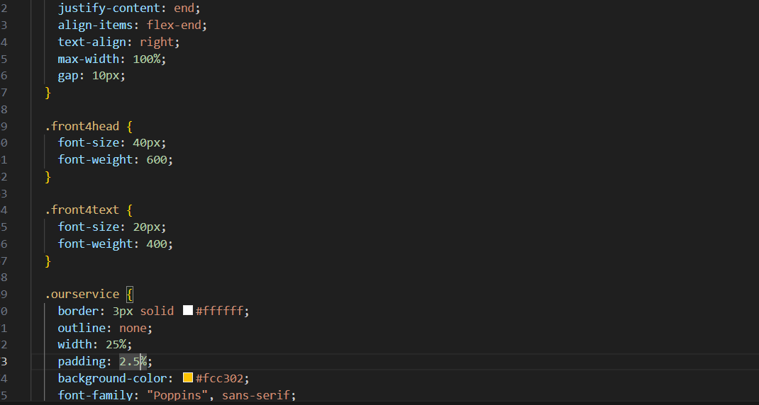

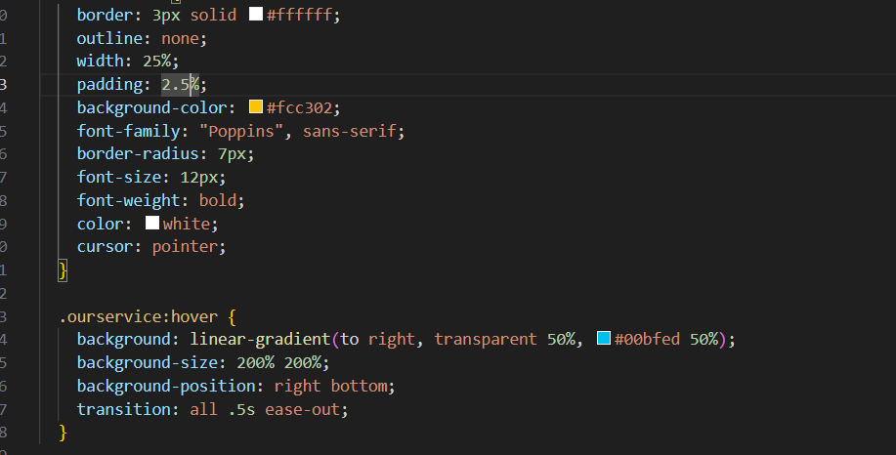

**Advt.css**

FEE-III, 22CS0014

32

**Desktop View Output:**

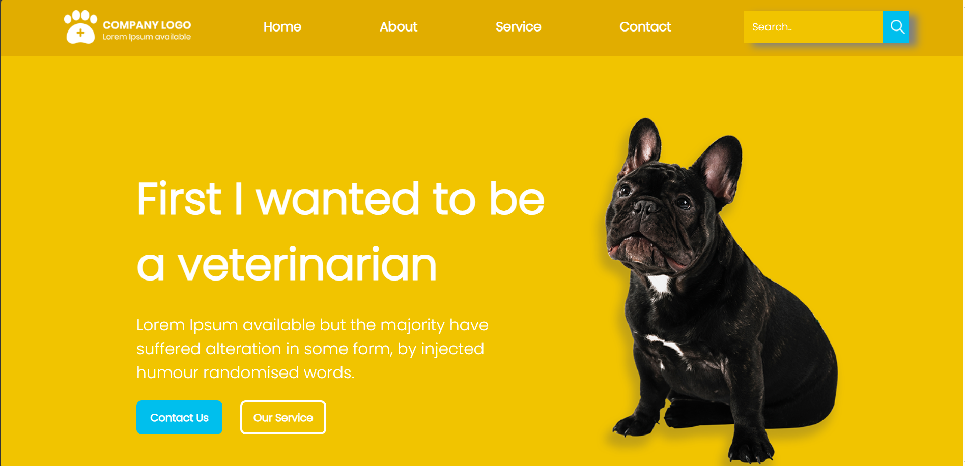

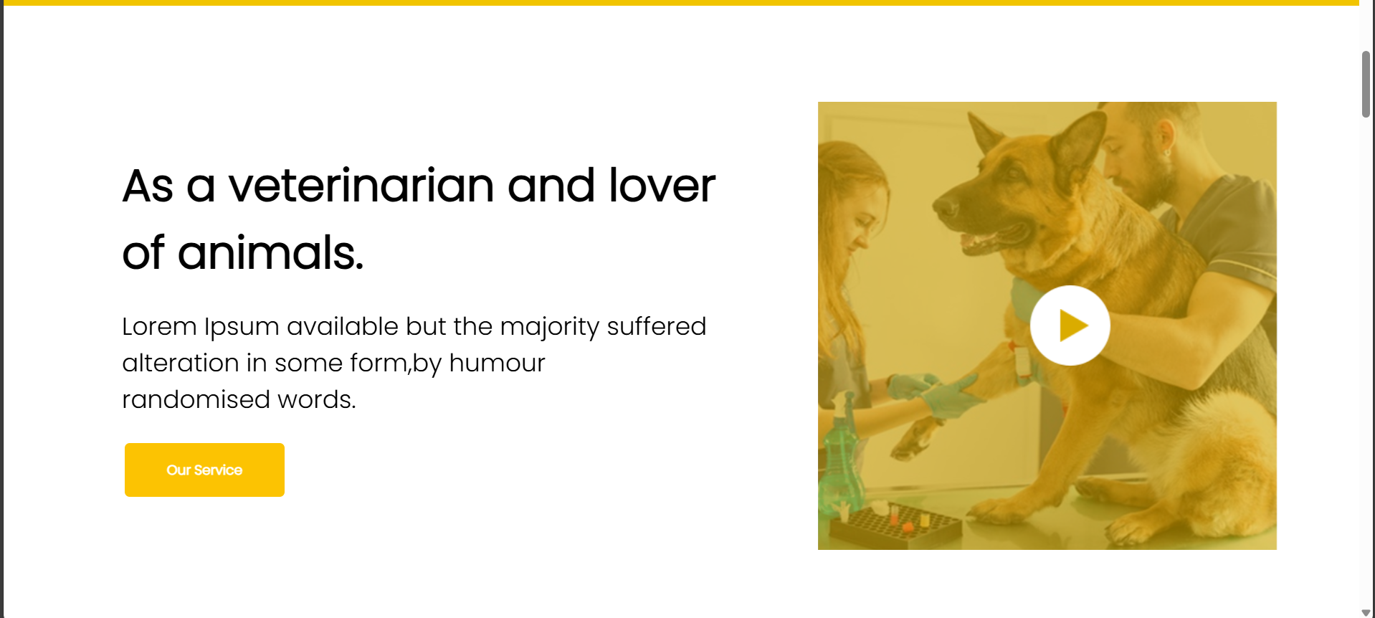

FEE-III ,22CS0014

33

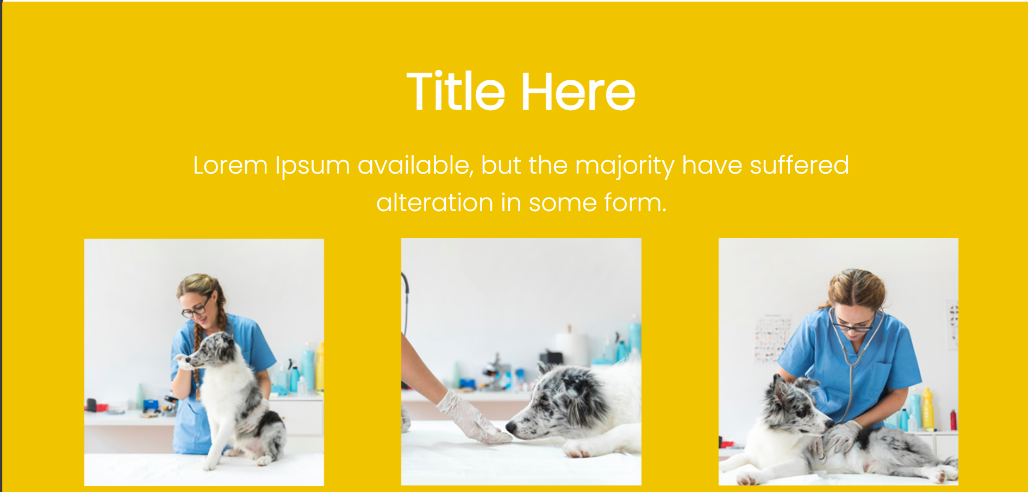

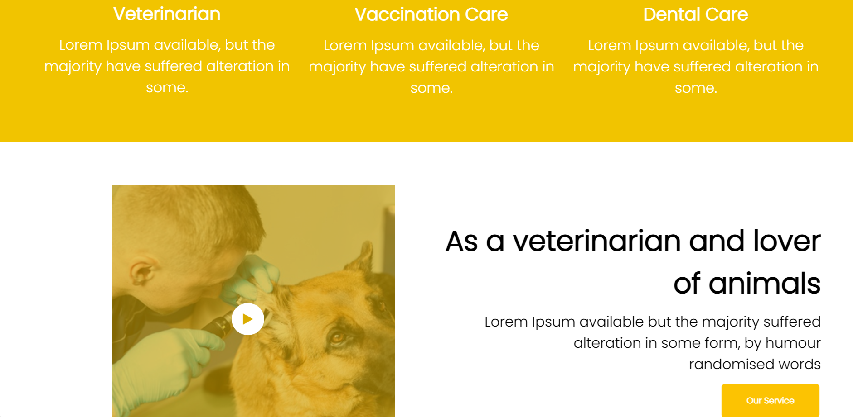

FEE-III, 22CS0014

34

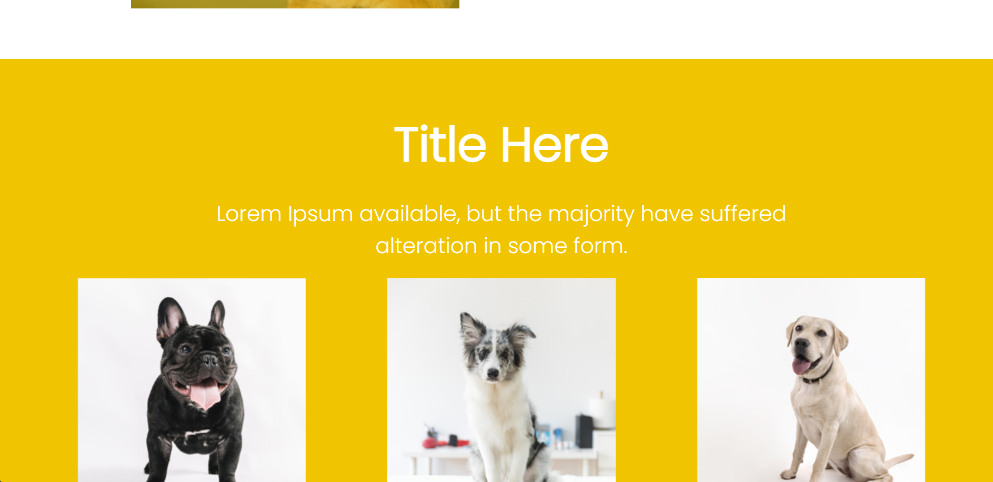 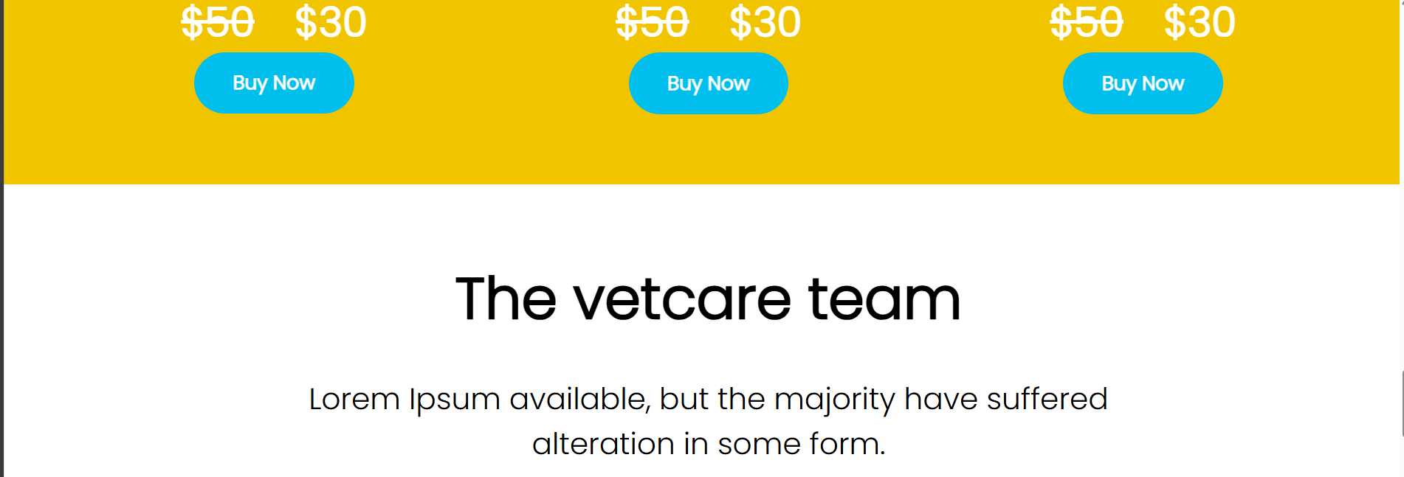 

FEE-III, 22CS0014

35

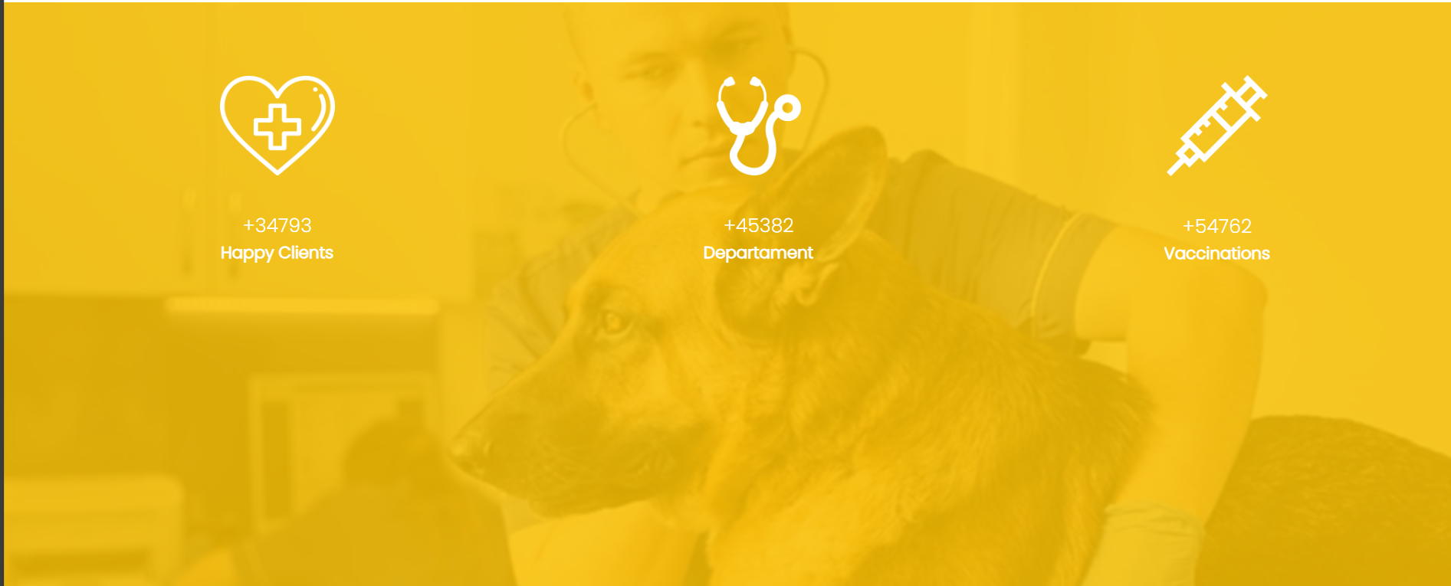

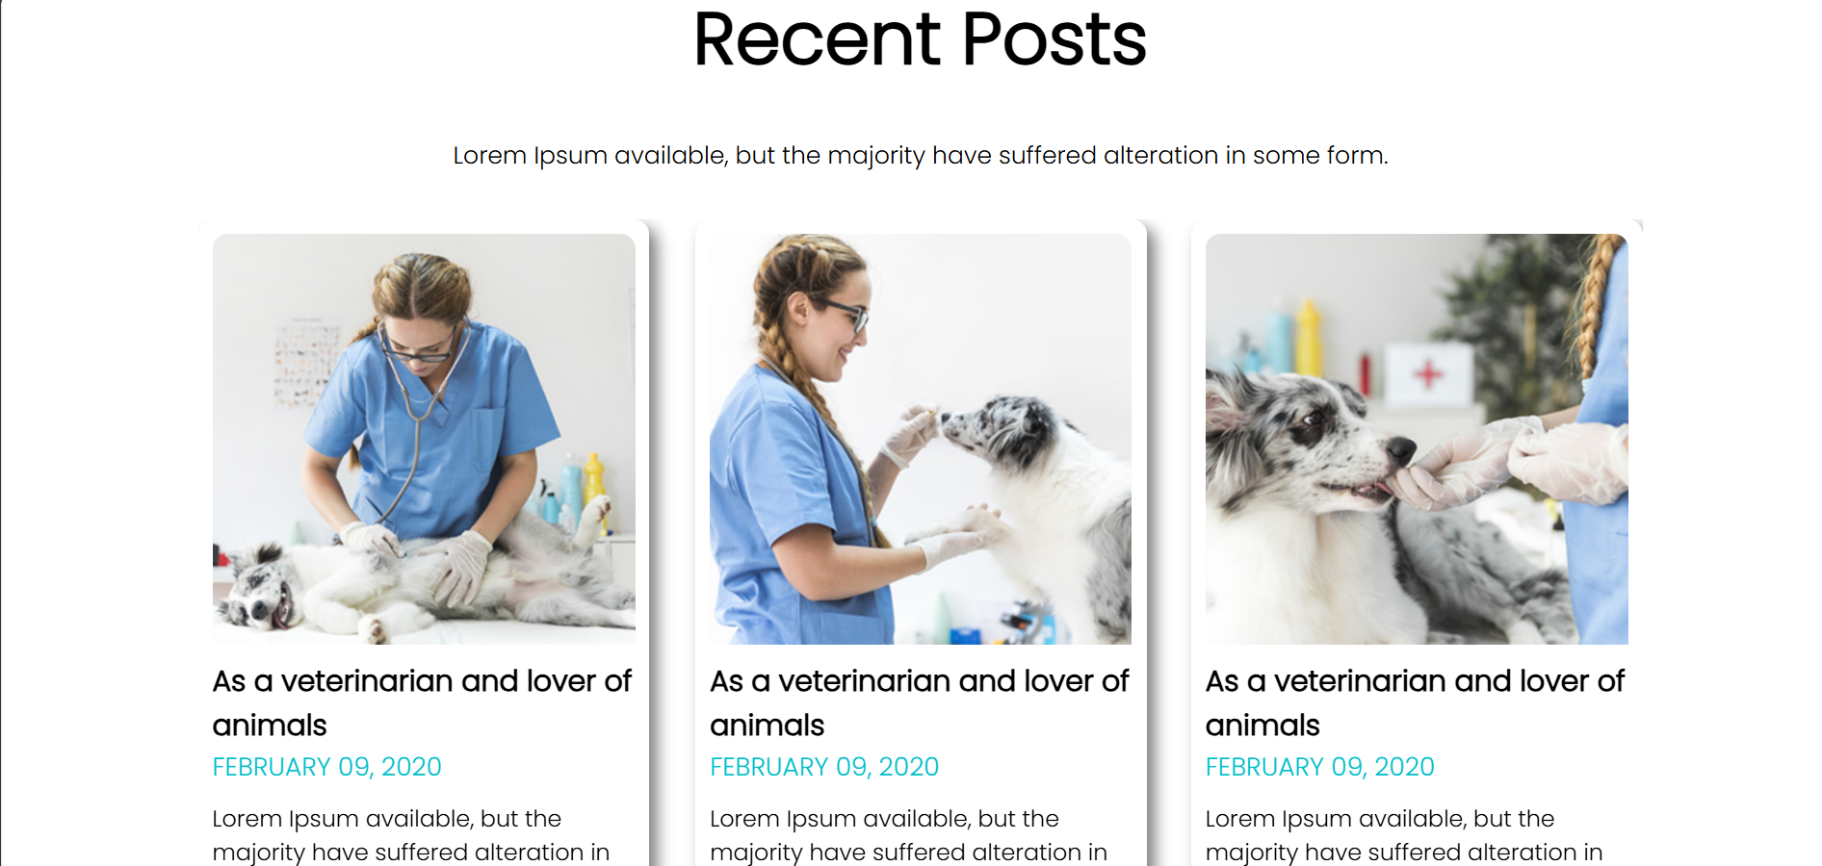

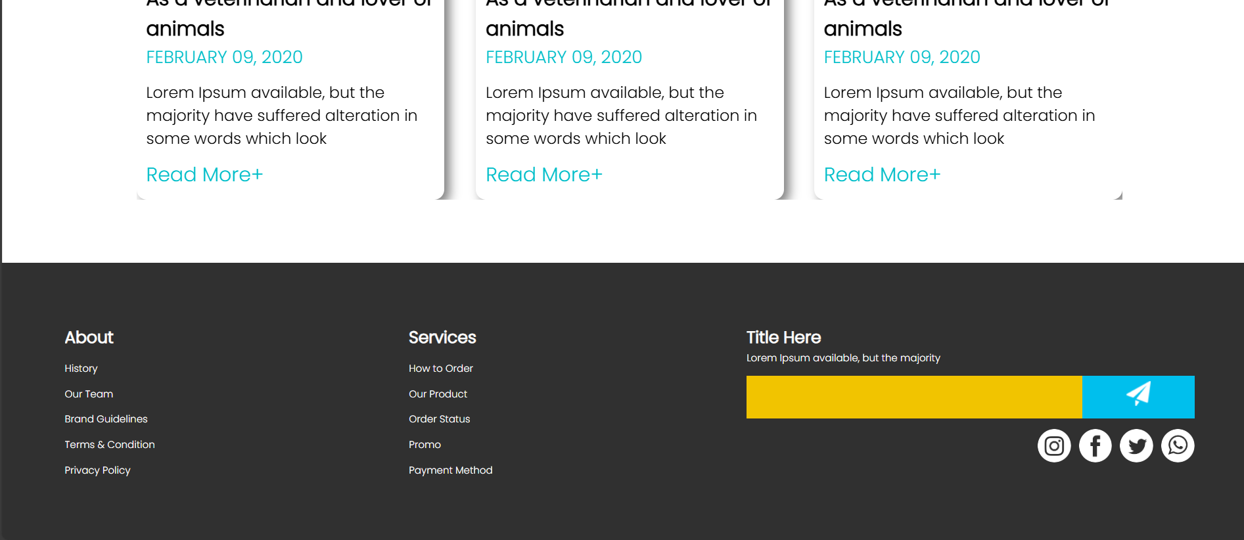

**Mobile View Output:**

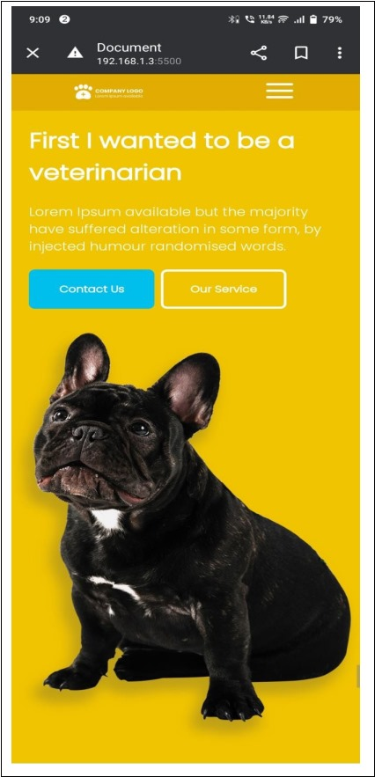

FEE-III, 22CS0014

37

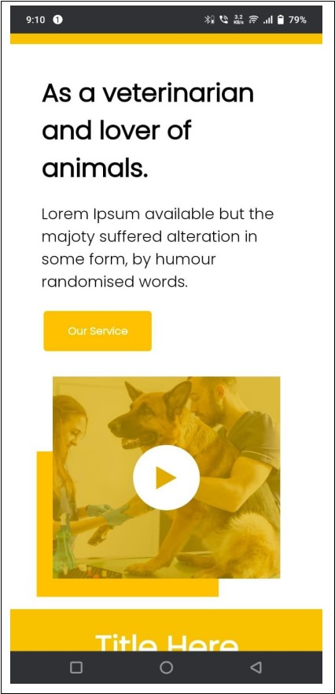

FEE-III, 22CS0014

38

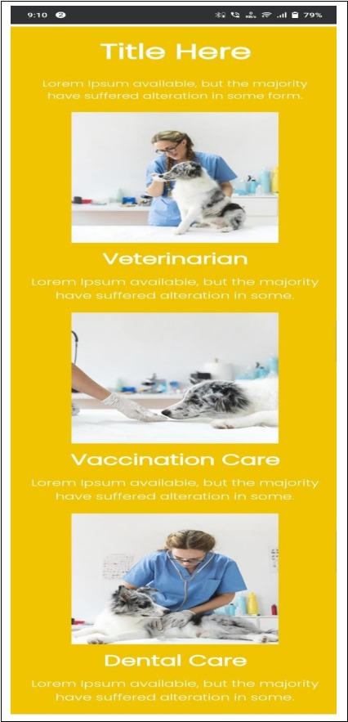

FEE-III, 22CS0014

39

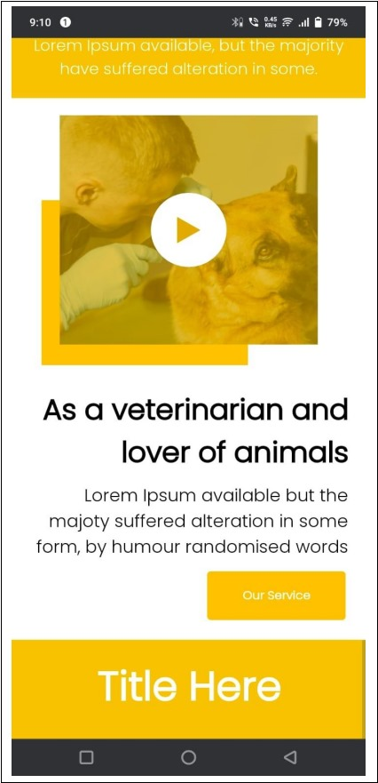

FEE-III, 22CS0014

40



FEE-III, 22CS0014

41

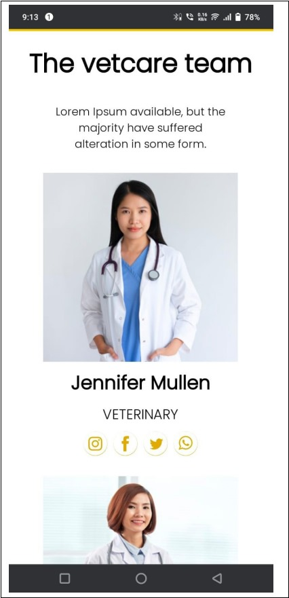

FEE-III ,22CS0014

42

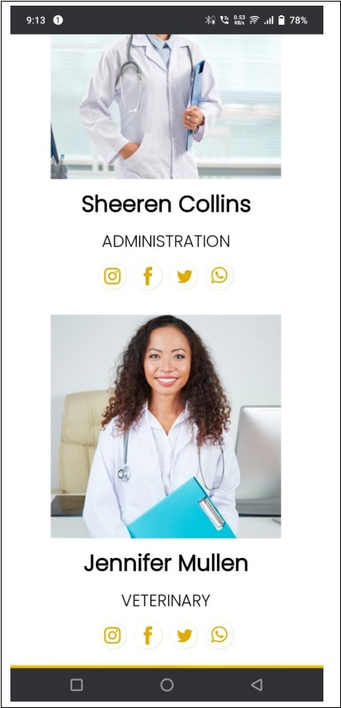

FEE-III, 22CS0014

43

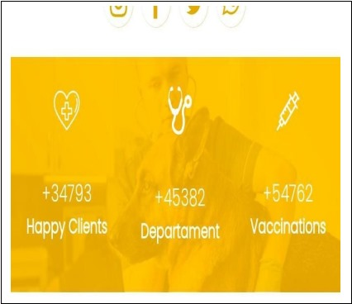

FEE-III, 22CS0014

44

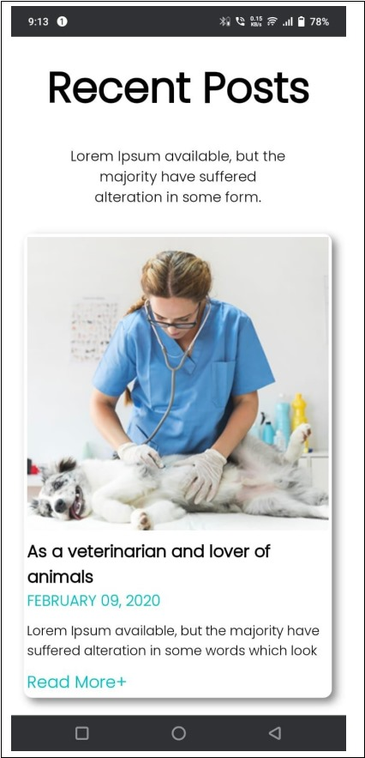

FEE-III ,22CS0014

45

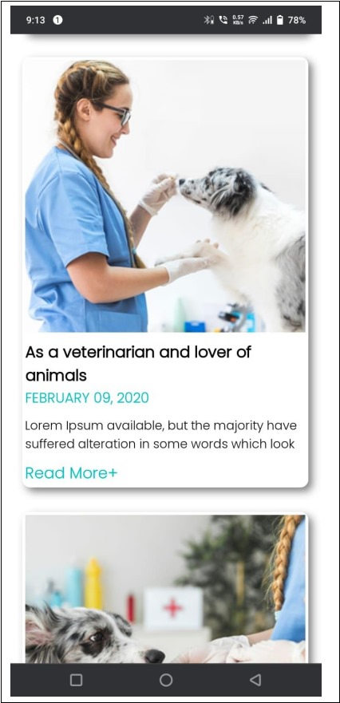

FEE-III, 22CS0014

46

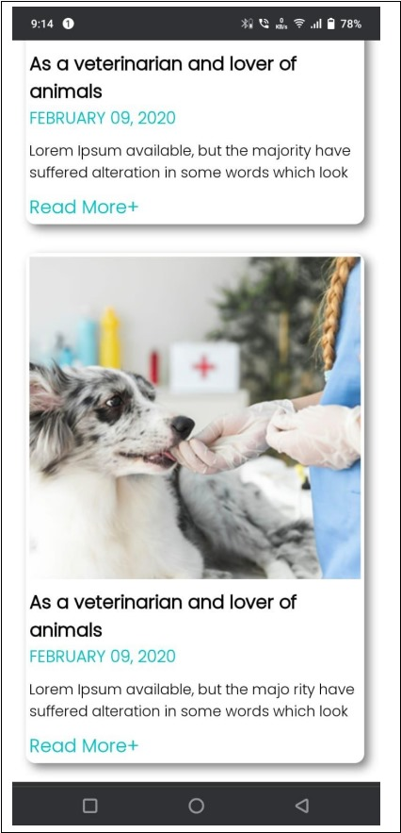

FEE-III, 22CS0014

47

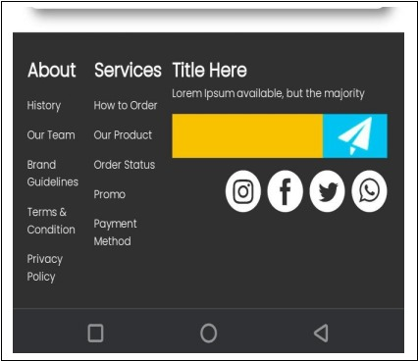

FEE-III, 22CS0014

48

**REFERENCES**

1. React JS:<https://react.dev/learn>

React JS is a popular JavaScript library for building user interfaces, particularly single-page applications. It allows developers to create reusable components, manage application state effectively, and build complex UIs from small, isolated pieces of code. The official React documentation offers comprehensive tutorials, examples, and explanations to help both beginners and experienced developers.

1. Photopea:-

Photopea is a free, web-based photo editor that supports various file formats, including PSD, XCF, Sketch, XD, and CDR. It offers a robust set of features similar to Adobe Photoshop, making it ideal for image editing, graphic design, and illustration. Users can access and edit images directly online without needing any software installation.

1. PSD Freebies :-

PSD Freebies provides a wide range of free Photoshop resources, including templates, UI kits, icons, and graphics. It is a valuable resource for designers looking for high-quality, downloadable PSD files to use in their projects. The website is regularly updated with new freebies to help designers stay creative and productive.

1. Google Fonts :-

Google Fonts is an extensive library of free, open-source fonts optimized for the web. It offers a diverse range of typefaces that can be easily integrated into web projects to enhance typography and design. The platform also provides a user-friendly interface to preview and select fonts, making it a go-to resource for designers and developers.

1. AOS (Animate On Scroll) :-

AOS (Animate On Scroll) is a small library that enables animations as you scroll down a webpage. It enhances user experience by adding subtle, smooth animations to elements as they come into view. The library is easy to use and highly customizable, allowing developers to create engaging, dynamic web pages with minimal effort.

FEE-III, 22CS0014

49